Report for linear programming – Corvallis temperature prediction

Part1:

To find best fitting curve of (1,3), (2,5), (3,7), (5,11), (7,14), (8,15), (10,19), there is a good approach which is minimize the maximum of |ax + b -y| for each point. If the maximum distance to the fitting curve can be minimized, then the optimal solution is found. Constrains of this problem are ax + b – y <= t, ax +b -y >= -t and t >=0 for each point

The best solution get from problem solver is: MAX=0.57, a = 1.71, b = 1.85.

Output of problem solver:

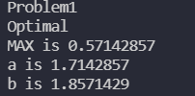

Plot of solution online:

This is an online best fit curve solver. It used minimize the sum of all distances, which is different than our way

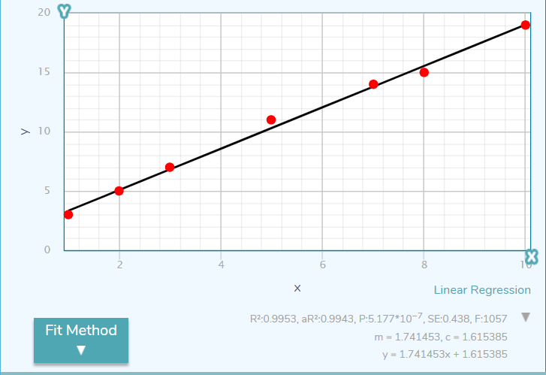

Result comparison:

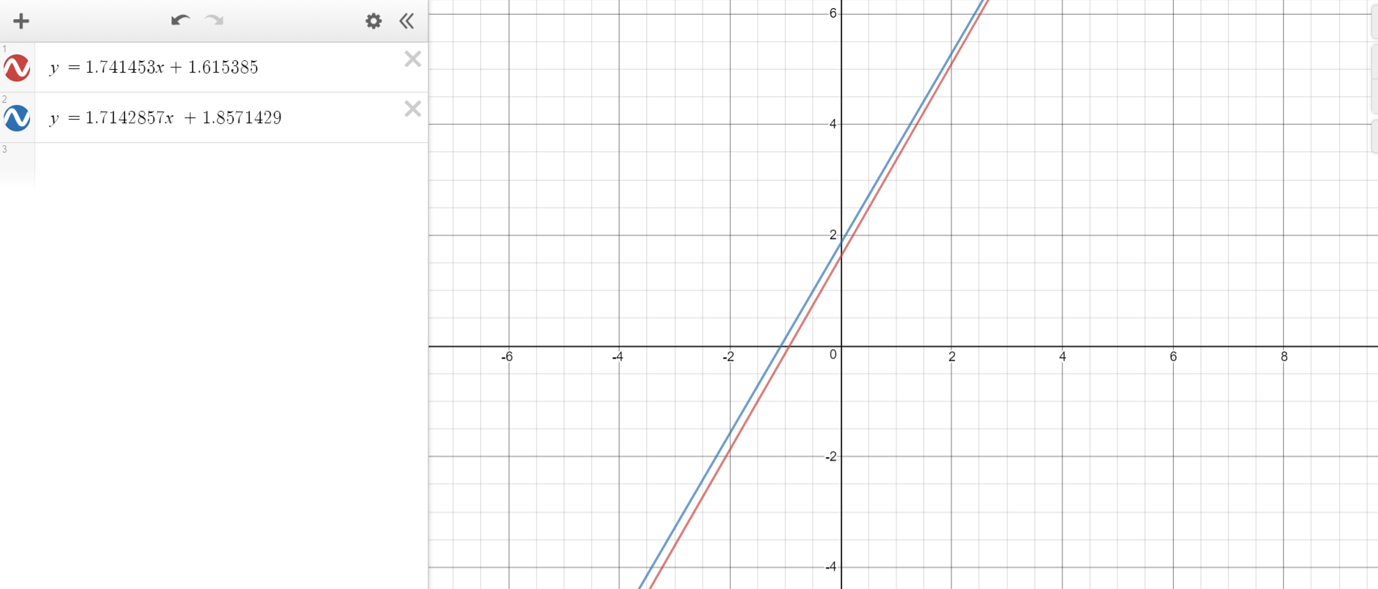

Part2:

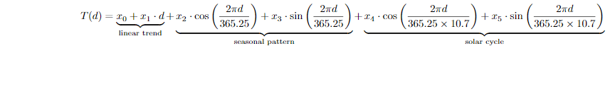

To find the best fitting curve of temperature data, 7 variables x0, x1, x2, x3, x4, x5 and MAX need to be found which can minimize the maximum of |T(d) -T |. So, this is a linear programming problem of minimizing

|T(d) -T | <= E for each point and MAX is the maximum value in the list of E. with constrains:

T(d) -T <= MAX, T(d) -T >= -MAX and MAX >=0

Optimal solution:

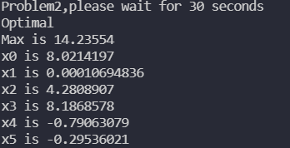

Best fitting curve:

The red starts are points from file and the blue curve is best fitting curve.

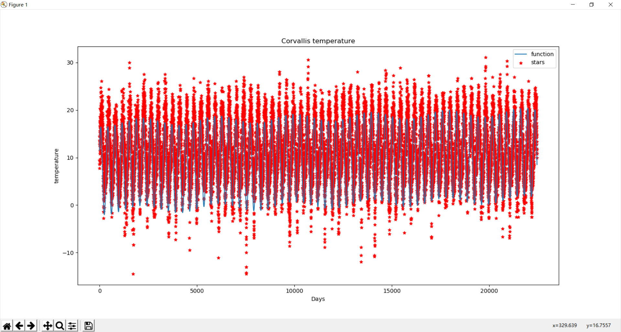

The polynomial part is T(d)=8.0214197 + 0.00010694836\*d with curve figure

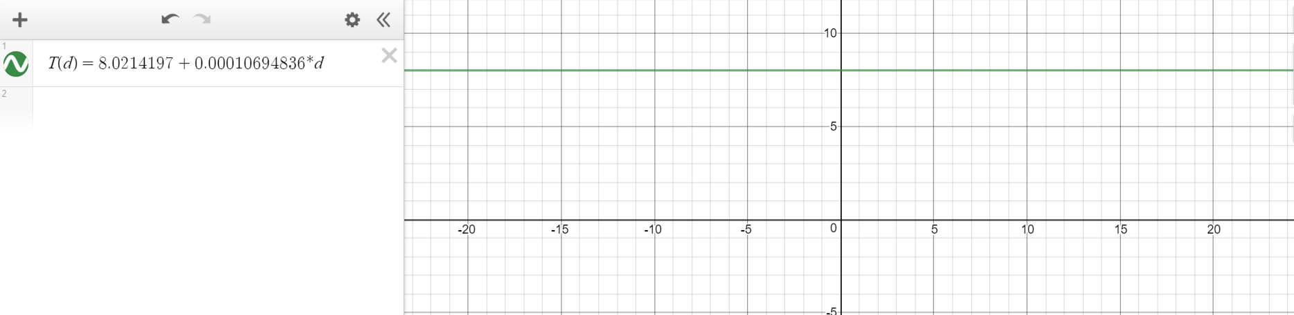

Temperature change after 100 years will be T(100\*365) - T(0) = 3.90361514. So, the temperature become warmer after a century year. The difference is 3.90361514 Celsius.